**Title: Implementing Data Backup and Recovery Strategies using AWS Backup:**

A Comprehensive Report on Data Backup and Recovery Strategies using AWS Backup

1. Introduction

a. Overview of data backup and recovery

* Data backup and recovery refer to the processes and practices involved in creating copies of important data and restoring that data in case of data loss, corruption, accidental deletion, or system failures.
* Data loss can occur due to various reasons such as hardware failure, natural disasters, cyber-attacks, or human error.
* Effective data backup and recovery strategies are crucial for ensuring data availability, minimizing downtime, and protecting against potential data loss.

b. Importance of implementing robust backup and recovery strategies

* Data Protection: Backup ensures that valuable data is protected from accidental loss or corruption, enabling organizations to recover and restore data to its original state.
* Business Continuity: In the event of data loss or system failure, a reliable backup and recovery solution helps minimize downtime and ensures continuity of business operations.
* Compliance and Legal Requirements: Many industries and jurisdictions have specific data retention and protection regulations. Implementing backup and recovery strategies helps organizations meet compliance requirements and avoid legal issues.
* Disaster Recovery: Backup plays a vital role in disaster recovery scenarios, allowing organizations to recover their systems and data after major disruptions like natural disasters, cyber-attacks, or ransomware incidents.

c. Introduction to AWS Backup as a solution

* AWS Backup is a fully managed backup service provided by Amazon Web Services (AWS).
* It simplifies the process of protecting data stored in various AWS services, including Amazon RDS (Relational Database Service), Amazon EBS (Elastic Block Store), Amazon DynamoDB, Amazon EFS (Elastic File System), and others.
* AWS Backup offers a centralized and automated approach to backup management, enabling users to define backup policies, schedule backups, set retention periods, and restore data easily.
* It provides a scalable and cost-effective solution for organizations seeking reliable data protection within the AWS ecosystem.
* AWS Backup also offers features like encryption, cross-region replication, and integration with other AWS services, making it a comprehensive backup and recovery solution.

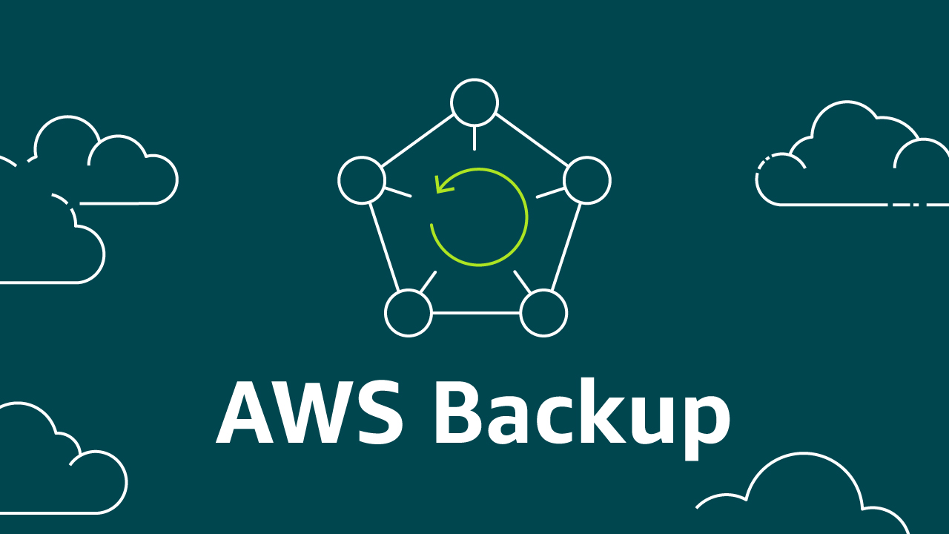

2. AWS Backup Overview

a. Explanation of AWS Backup service

* AWS Backup is a centralized backup service provided by Amazon Web Services (AWS) that simplifies the process of protecting data stored in AWS services.
* It offers a unified solution for backup management, enabling users to automate and manage backups across multiple AWS resources and services.
* AWS Backup eliminates the need for custom backup scripts and provides a streamlined approach to data protection in the AWS environment.

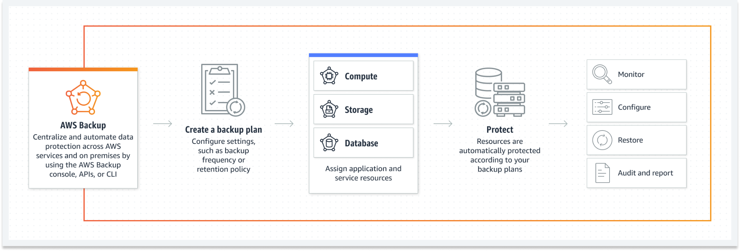

b. Key features and capabilities

* Centralized Backup Management: Users can manage and configure backups for multiple AWS services through a single console, simplifying the backup process and providing a unified view of backup operations.
* Policy-based Automation: AWS Backup allows users to define backup policies based on desired backup frequency, retention period, and backup window. These policies can be easily applied to resources, eliminating the need for manual backup configuration.
* Application-consistent Backups: AWS Backup ensures application-consistent backups by leveraging native APIs and integration with AWS services. This ensures the integrity of backup data, enabling reliable recovery of applications and databases.
* Cross-Region Backup and Replication: AWS Backup supports cross-region backup and replication, allowing users to create backups in different AWS regions for enhanced data protection and disaster recovery.
* Incremental Backups: AWS Backup performs incremental backups, capturing only the changes made since the last backup. This minimizes the backup window and reduces storage costs.
* Point-in-Time Recovery: AWS Backup enables point-in-time recovery, allowing users to restore data to a specific moment in time. This is particularly useful for recovering from data corruption or accidental deletion.
* Data Lifecycle Management: AWS Backup supports data lifecycle management, allowing users to define rules for transitioning backups to different storage classes based on their age, reducing storage costs.

c. Compatibility with various AWS services

AWS Backup is compatible with a wide range of AWS services, including but not limited to:

* Amazon RDS: AWS Backup provides automated backups for Amazon RDS database instances, ensuring data durability and enabling point-in-time recovery.
* Amazon EBS: AWS Backup offers backup and recovery for Amazon Elastic Block Store (EBS) volumes, providing data protection for block-level storage.
* Amazon DynamoDB: AWS Backup supports automated backups and on-demand backups for Amazon DynamoDB, enabling easy recovery of NoSQL database tables.
* Amazon EFS: AWS Backup allows users to create and manage backups of Amazon Elastic File System (EFS), providing file-level backup and recovery.
* AWS Storage Gateway: AWS Backup integrates with AWS Storage Gateway, enabling backup and recovery of on-premises data and hybrid cloud environments.
* AWS Lambda: AWS Backup supports backing up AWS Lambda functions, ensuring the availability of serverless code and configurations.
* AWS Aurora: AWS Backup provides automated backup and restore capabilities for Amazon Aurora database clusters.

3. Data Backup Strategy

a. Identifying critical data and systems

* The first step in developing a data backup strategy is to identify the critical data and systems within your organization.
* This involves understanding which data and systems are crucial for business operations and need to be prioritized for backup. Identify databases, files, applications, configurations, and any other data or systems that are essential for the organization's functionality and data integrity.

b. Defining backup frequency and retention policies

* Once the critical data and systems have been identified, determine the appropriate backup frequency and retention policies.
* This involves establishing how often backups should be performed based on the frequency of data changes and the tolerance for potential data loss.
* Consider factors such as the cost of downtime, data volatility, and compliance requirements.
* Additionally, define retention policies to determine how long backups should be retained to meet business and regulatory requirements.

c. Selection of appropriate backup methods (full, incremental, etc.)

Choose the appropriate backup methods based on the identified critical data and systems. Common backup methods include:

* Full Backup: A complete backup of all selected data and systems, which is time and resource-intensive but provides a comprehensive restore point.
* Incremental Backup: Backing up only the changes since the last backup, reducing backup time and storage requirements. However, restoring from incremental backups may require the full backup plus all subsequent incremental backups.
* Differential Backup: Backing up only the changes since the last full backup, which reduces restore time compared to incremental backups.

Consider the recovery point objectives (RPOs) and recovery time objectives (RTOs) established during the data backup strategy planning to determine the appropriate backup method.

d. Build a recovery strategy that brings your workload back up or avoids downtime within the acceptable

* RTO is the acceptable delay between the interruption of service and restoration of service.
* RPO is the acceptable amount of time since the last data recovery point.

Consider a granular backup strategy that includes all of the following:

* Continuous backup cadence
* Point-in-Time Recovery (PITR)
* File-level recovery
* Application data–level recovery
* Volume-level recovery
* Instance-level recovery

4. AWS Backup Configuration

a. Setting up AWS Backup service

* Sign in to the AWS Management Console and open the AWS Backup service.
* Choose "Get Started" to begin configuring AWS Backup.
* Follow the prompts to set up your backup vault, which is a container for storing backups.
* Configure the backup vault settings, including the name, encryption settings, and tags.

Choose the AWS services you want to back up, such as Amazon RDS, Amazon EBS, or Amazon DynamoDB, and follow the specific setup instructions for each service.

b. Integration with AWS services (RDS, EBS, DynamoDB, etc.)

* Identify the AWS services you want to back up, such as Amazon RDS, Amazon EBS volumes, or Amazon DynamoDB tables.
* Enable backups for the desired services by either using the AWS Management Console or programmatically through AWS APIs.
* Configure backup settings specific to each service, such as the frequency of backups and the backup window.

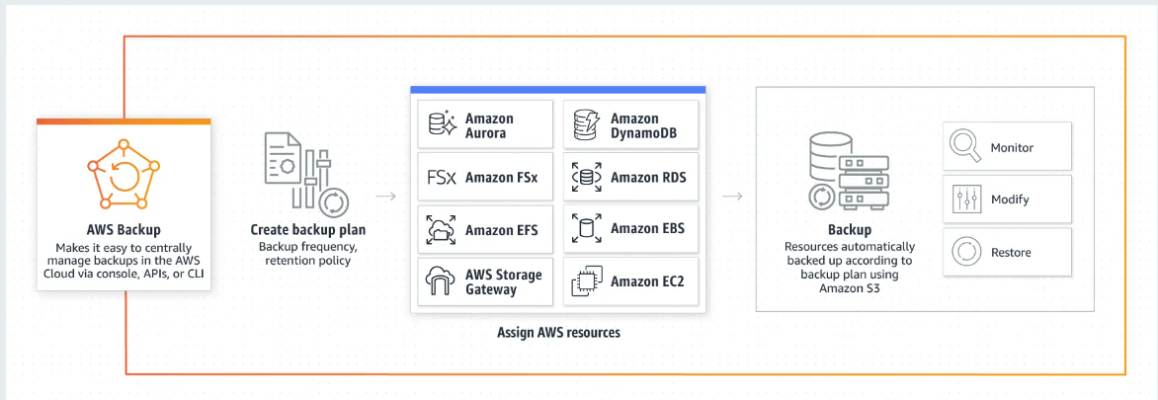

c. Configuring backup schedules and retention periods

* Determine the appropriate backup schedule based on your recovery point objectives (RPOs) and business requirements.
* Define backup rules and assign them to backup plans.
* Specify the backup frequency (e.g., daily, weekly) and the desired backup window for each backup rule.
* Configure retention periods to determine how long backups should be stored before being deleted.

d. Encryption and security considerations

* Enable encryption for backup data at rest using AWS Key Management Service (KMS) and customer-managed CMKs.
* Define encryption settings during the backup plan configuration to ensure data is encrypted before being stored.
* Implement IAM policies and roles to control access to AWS Backup resources and operations.
* Follow AWS security best practices for protecting backup data, including securing IAM credentials, enabling multi-factor authentication, and monitoring access logs.

5. Data Recovery Strategy

a. Defining recovery point objectives (RPOs) and recovery time objectives (RTOs)

* Establishing the correct recovery objective targets at an application level is a critical part of business continuity planning.
* RTO stands for Recovery Time Objective and is a measure of how quickly after an outage an application must be available again.
* RPO, or Recovery Point Objective, refers to how much data loss your application can tolerate. Another way to think about RPO is how old can the data be when this application is recovered?
* With both RTO and RPO, the targets are measured in hours, minutes, or seconds, with lower numbers representing less downtime or less data loss. Within the context of a Business Continuity Plan, applications having similar RTO targets are grouped together in Tiers, with Tier 0 having the lowest RTO.

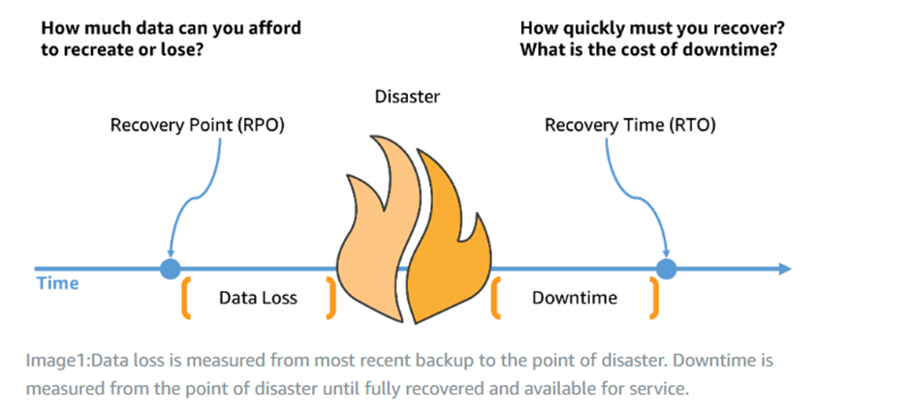

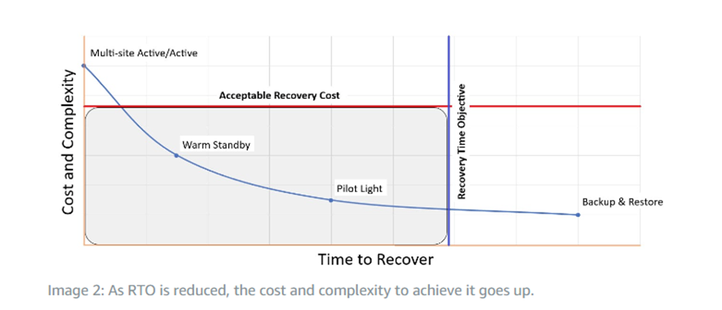

b. Selection of appropriate recovery methods (point-in-time restore, disaster recovery, etc.)

Disaster recovery strategies available to you within AWS can be broadly categorized into four approaches, ranging from the low cost and low complexity of making backups to more complex strategies using multiple active Regions. Active/passive strategies use an active site (such as an AWS Region) to host the workload and serve traffic. The passive site (such as a different AWS Region) is used for recovery. The passive site does not actively serve traffic until a failover event is triggered.

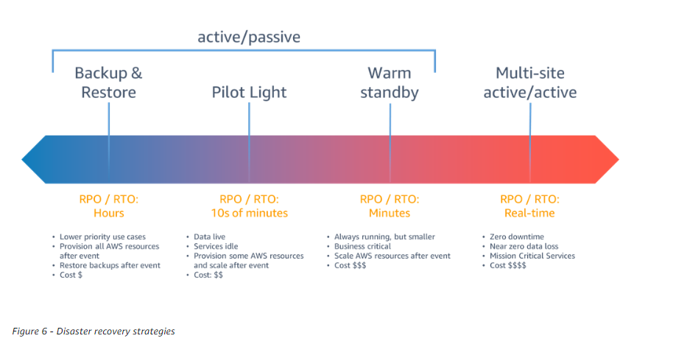

**Backup and restore**

Backup and restore is a suitable approach for mitigating against data loss or corruption. This approach can also be used to mitigate against a regional disaster by replicating data to other AWS Regions, or to mitigate lack of redundancy for workloads deployed to a single Availability Zone. In addition to data, you must redeploy the infrastructure, configuration, and application code in the recovery Region. To enable infrastructure to be redeployed quickly without errors, you should always deploy using infrastructure as code (IaC) using services such as AWS CloudFormation or the AWS Cloud Development Kit (AWS CDK). Without IaC, it may be complex to restore workloads in the recovery Region, which will lead to increased recovery times and possibly exceed your RTO. In addition to user data, be sure to also back up code and configuration, including Amazon Machine Images (AMIs) you use to create Amazon EC2 instances. You can use AWS CodePipeline to automate redeployment of application code and configuration.

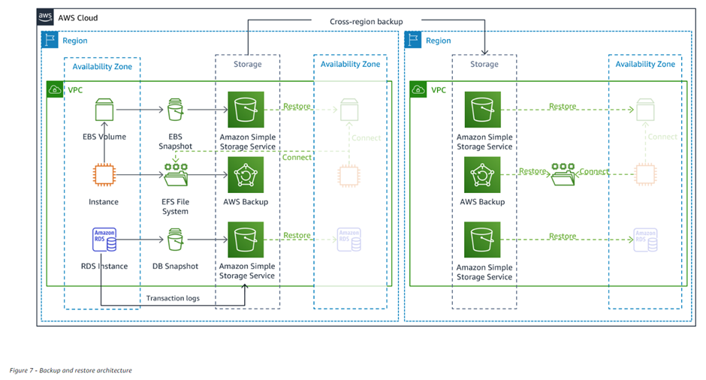

**Pilot light**

With the pilot light approach, you replicate your data from one Region to another and provision a copy of your core workload infrastructure. Resources required to support data replication and backup, such as databases and object storage, are always on. Other elements, such as application servers, are loaded with application code and configurations, but are "switched off" and are only used during testing or when disaster recovery failover is invoked. In the cloud, you have the flexibility to deprovision resources when you do not need them, and provision them when you do. A best practice for “switched off” is to not deploy the resource, and then create the configuration and capabilities to deploy it (“switch on”) when needed. Unlike the backup and restore approach, your core infrastructure is always available and you always have the option to quickly provision a full scale production environment by switching on and scaling out your application servers.

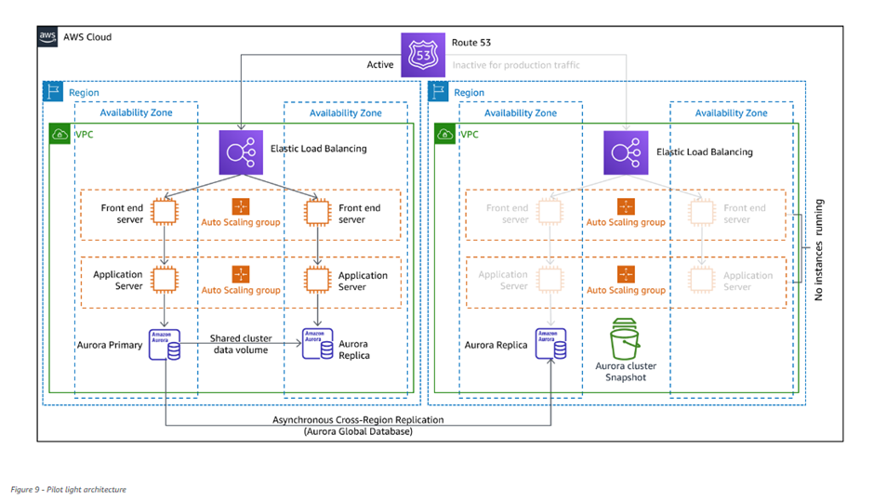

**Warm standby**

The warm standby approach involves ensuring that there is a scaled down, but fully functional, copy of your production environment in another Region. This approach extends the pilot light concept and decreases the time to recovery because your workload is always-on in another Region. This approach also allows you to more easily perform testing or implement continuous testing to increase confidence in your ability to recover from a disaster.

**Multi-site active/active:**

You can run your workload simultaneously in multiple Regions as part of a multi-site active/active or hot standby active/passive strategy. Multi-site active/active serves traffic from all regions to which it is deployed, whereas hot standby serves traffic only from a single region, and the other Region(s) are only used for disaster recovery. With a multi-site active/active approach, users are able to access your workload in any of the Regions in which it is deployed. This approach is the most complex and costly approach to disaster recovery, but it can reduce your recovery time to near zero for most disasters with the correct technology choices and implementation (however data corruption may need to rely on backups, which usually results in a non-zero recovery point). Hot standby uses an active/passive configuration where users are only directed to a single region and DR regions do not take traffic. Most customers find that if they are going to stand up a full environment in the second Region, it makes sense to use it active/active. Alternatively, if you do not want to use both Regions to handle user traffic, then Warm Standby offers a more economical and operationally less complex approach.

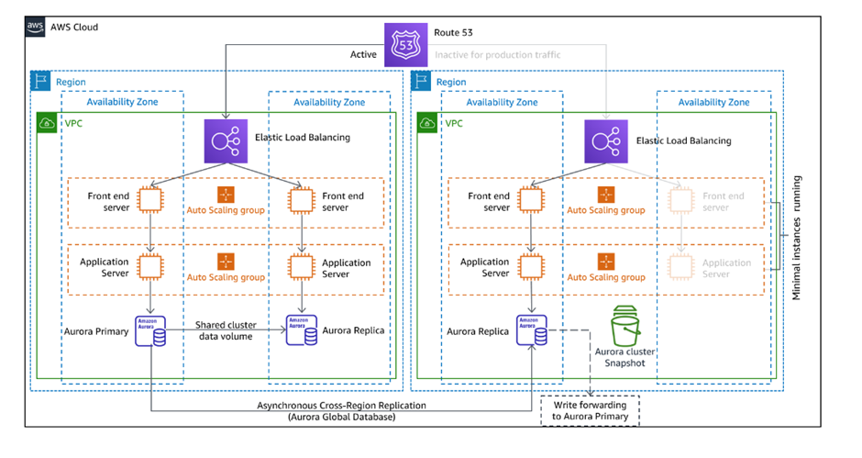

c. Utilizing AWS Backup for data restoration

* AWS Backup is a fully managed backup service centralizing and automating the backup of data across AWS services. AWS Backup provides an orchestration layer that integrates Amazon CloudWatch, AWS CloudTrail, AWS Identity and Access Management (IAM), AWS Organizations, and other services. This centralized, AWS Cloud native solution provides global backup capabilities that can help you achieve your disaster recovery and compliance requirements. Using AWS Backup, you can centrally configure backup policies and monitor backup activity for AWS resources.
* AWS Backup is an ideal solution for implementing standard backup plans for your AWS resources across your AWS accounts and Regions. Because AWS Backup supports multiple AWS resource types, it makes it easier to maintain and implement a backup strategy for workloads using multiple AWS resources that need to be backed up collectively. AWS Backup also enables you to collectively monitor a backup and restore operation that involves multiple AWS resources.
* If you have compliance and audit requirements, you can use the AWS Backup Audit Manager feature to create audit frameworks and reports to support your compliance requirements. The AWS Backup Vault Lock feature also supports compliance requirements by enforcing a write-once, read-many (WORM) configuration for all your backups stored in an backup vault in AWS Backup.
* A key differentiator for AWS Backup is support for Organizations. Using this support, you can define and manage backup policies at the organization or organizational unit level and automatically have those policies implemented for each related AWS account and Region. As you onboard new AWS accounts and Regions, you don’t have to define and manage backup plans separately.

d. Testing and validating recovery processes

* Test disaster recovery implementation to validate the implementation and regularly test failover to your workload’s DR Region to ensure that RTO and RPO are met.
* A pattern to avoid is developing recovery paths that are rarely executed. For example, you might have a secondary data store that is used for read-only queries. When you write to a data store and the primary fails, you might want to fail over to the secondary data store.
* If you don’t frequently test this failover, you might find that your assumptions about the capabilities of the secondary data store are incorrect. The capacity of the secondary, which might have been sufficient when you last tested, might no longer be able to tolerate the load under this scenario, or service quotas in the secondary Region might not be sufficient.

6. Monitoring and Compliance

a. Utilizing AWS CloudWatch for backup monitoring

* AWS Backup adds the ability to monitor your AWS Backup metrics and events via Amazon CloudWatch. AWS Backup enables you to centralize and automate data protection across AWS services and accounts, helping you support your regulatory compliance obligations and meet business continuity goals.
* You can monitor your overall AWS Backup health in CloudWatch by tracking metrics on your backup, copy, and restore jobs across different job statuses (created, running, completed, failed, etc.) across the eight currently supported AWS services, including Amazon Elastic Compute Cloud (Amazon EC2) instances, Amazon Elastic Block Store (Amazon EBS) volumes, Amazon Relational Database Service (RDS) databases (including Amazon Aurora clusters), Amazon DynamoDB tables, Amazon Elastic File System (EFS), Amazon FSx for Lustre, Amazon FSx for Windows File Server, and AWS Storage Gateway volumes. You can also set up alarms to receive notifications on job failures to quickly diagnose and fix backup policies to avoid further failures.
* Additionally, you can use CloudWatch Events to receive notifications on AWS Backup events. For example, you can use Amazon Simple Notification Service (Amazon SNS) or AWS Lambda to set up event notifications to identify misconfigurations or potential threats and take corrective measures.

b. Generating backup and recovery reports

* To backup a plan you can create a report plan to automate the creation of your reports and define their destination Amazon S3 bucket. A report plan requires that you have an S3 bucket to receive your reports.

c. Ensuring compliance with industry regulations (GDPR, HIPAA, etc.)

* The AWS Compliance Program helps customers to understand the robust controls in place at AWS to maintain security and compliance of the cloud. By tying together governance-focused, audit-friendly service features with applicable compliance or audit standards, AWS Compliance Enablers build on traditional programs, helping customers to establish and operate in an AWS security control environment
* A growing number of healthcare providers, payers, and IT professionals are using AWS's utility-based cloud services to process, store, and transmit protected health information (PHI).
* AWS enables covered entities and their business associates subject to the U.S. Health Insurance Portability and Accountability Act of 1996 (HIPAA) to use the secure AWS environment to process, maintain, and store protected health information.

d. Auditing and logging activities

* Monitoring is an important part of maintaining the reliability, availability, and performance of Audit Manager and your other AWS solutions. AWS provides the following monitoring tools to watch Audit Manager, report when something is wrong, and take automatic actions.
* AWS CloudTrail captures API calls and related events made by or on behalf of your AWS account and delivers the log files to an Amazon S3 bucket that you specify. You can identify which users and accounts called AWS, the source IP address from which the calls were made, and when the calls occurred.

7. Cost Optimization

a. Understanding AWS Backup pricing model

AWS Backup offers a flexible and scalable pricing model based on the resources you back up and store. The pricing factors to consider include:

* Backup storage: AWS Backup charges for the storage consumed by your backups, including both the backup data and any associated metadata. The storage costs vary depending on the storage class used.
* Backup operations: AWS Backup also charges for backup and restore operations, such as creating, copying, or restoring backups. The pricing varies based on the size and number of operations performed.

b. Implementing cost-effective backup strategies

To optimize costs while using AWS Backup, consider the following strategies:

* Backup frequency: Assess the frequency at which backups are necessary for your data. Determine if real-time backups are required or if periodic backups at specific intervals suffice. Adjusting the backup frequency can help reduce costs.
* Backup retention: Define a proper retention policy for backups. Retain backups for as long as necessary to meet compliance or business requirements, but avoid unnecessarily long retention periods to reduce storage costs.
* Backup window: Schedule backups during off-peak hours to take advantage of reduced data transfer costs.
* Deduplication and compression: Utilize AWS Backup's built-in deduplication and compression features to reduce storage requirements and optimize costs.

c. Utilizing storage classes and data lifecycle management

AWS Backup supports different storage classes, each with its own cost structure. By choosing the appropriate storage class based on your data's access patterns and recovery requirements, you can optimize costs. For example:

* Glacier storage class: Use Glacier for long-term archival backups with infrequent access requirements.
* Standard storage class: Utilize the standard storage class for frequently accessed backups that require low-latency recovery.
* Intelligent Tiering storage class: Leverage the Intelligent Tiering class for backups with varying access patterns, as it automatically moves data between different storage tiers to optimize costs.

d. Monitoring and optimizing backup costs

AWS Backup provides monitoring and reporting capabilities to help you analyze and optimize backup costs. Consider the following practices:

* Cost Explorer: Utilize AWS Cost Explorer to visualize and understand your backup costs. It provides insights into cost trends, allows you to set cost allocation tags, and helps identify potential cost-saving opportunities.
* AWS Budgets: Set up AWS Budgets to monitor and control backup costs. You can create budgets based on cost thresholds and receive notifications when costs exceed predefined limits.
* Trusted Advisor: Leverage AWS Trusted Advisor to receive recommendations on optimizing backup costs, such as identifying unused or idle resources that can be deleted or downsized.

8. Best Practices and Recommendations

a. Implementing a multi-region backup strategy

A multi-region backup strategy is a best practice for protecting your data from regional outages. By storing your backups in multiple regions, you can ensure that you can still access your data even if one region is unavailable.

To implement a multi-region backup strategy, you can use AWS Backup to create backup vaults in multiple regions. You can then configure your backup jobs to store backups in the vaults in the different regions.

b. Utilizing AWS Backup with AWS Organizations for centralized management

AWS Backup can be used with AWS Organizations to centralize the management of backups across multiple accounts. This can help you to simplify the management of your backups and to ensure that all of your accounts are compliant with your backup policies.

To utilize AWS Backup with AWS Organizations, you need to create an organization and then add your accounts to the organization. You can then create a backup policy for the organization and then assign the policy to your accounts.

c. Implementing cross-account backups for enhanced security

Cross-account backups can be used to enhance the security of your backups. By allowing one account to access the backups in another account, you can ensure that you have access to your backups even if one account is compromised.

To implement cross-account backups, you need to create an IAM role that allows the account that will be accessing the backups to access the backup vaults in the other account. You can then attach the role to the users or groups in the account that will be accessing the backups.

d. Regularly reviewing and updating backup and recovery strategies

It is important to regularly review and update your backup and recovery strategies. This will help you to ensure that your strategies are still effective and that they meet your changing needs.

As part of your regular reviews, you should assess your backup and recovery strategies against your business requirements. You should also review your backup and recovery logs to identify any potential issues.

9. Case Studies

a. Real-world examples of organizations using AWS Backup

* Santos is an independent oil and gas producer in the Asia-Pacific region. They use AWS Backup to automate their backup processes and to ensure that their data is protected from loss.
* Wise is a financial services company that uses AWS Backup to protect their customer data. They have been able to reduce their backup costs by 50% and to improve their backup compliance.
* ZS Associates is a consulting firm that uses AWS Backup to protect their intellectual property. They have been able to simplify their backup management and to improve their backup recovery time.

b. Success stories and lessons learned

* Santos was able to reduce their backup costs by 50% by automating their backup processes with AWS Backup. They also improved their backup compliance by using AWS Backup to ensure that their data is backed up according to their company's policies.
* Wise was able to improve their backup recovery time by using AWS Backup. They were able to restore a customer's database in just 15 minutes, which helped them to avoid a significant financial loss.
* ZS Associates was able to simplify their backup management by using AWS Backup. They were able to centralize their backup management in a single console, which made it easier to track and manage their backups.

c. Benefits achieved through implementing AWS Backup

* Cost savings: AWS Backup can help you to save money on your backup costs by automating your backup processes and by using cost-efficient storage options.
* Compliance: AWS Backup can help you to improve your backup compliance by providing you with a centralized console to manage your backups and by ensuring that your backups are compliant with your company's policies.
* Recovery time: AWS Backup can help you to improve your backup recovery time by providing you with a fast and easy way to restore your data.
* Security: AWS Backup uses industry-leading security features to protect your data, including encryption, access control, and auditing.

10. Conclusion

a. Recap of key points discussed

In this report, we have discussed the importance of implementing robust data backup and recovery strategies. We have also discussed AWS Backup as a reliable solution for data protection. Here are some of the key points that we have discussed:

* Data backup and recovery is essential for protecting your data from loss or corruption.
* AWS Backup is a fully managed, policy-based service that can help you to automate your backup processes and to ensure that your data is protected.
* AWS Backup offers a wide range of features, including cross-account backups, multi-region backups, and ransomware recovery.
* AWS Backup is a reliable and secure solution for data protection.

b. Importance of implementing robust data backup and recovery strategies

In today's digital world, data is more important than ever. Businesses rely on their data to operate, and the loss of data can have a devastating impact. That's why it's so important to implement robust data backup and recovery strategies.

A robust data backup and recovery strategy should include the following elements:

* Regular backups of your data.
* A secure location to store your backups.
* A process for restoring your data in the event of a disaster.

c. AWS Backup as a reliable solution for data protection

AWS Backup is a reliable and secure solution for data protection. It offers a wide range of features that can help you to protect your data from loss or corruption. AWS Backup is also a cost-effective solution, and it can help you to save money on your backup costs.

d. Future trends and developments in data backup and recovery

The future of data backup and recovery is likely to be driven by the following trends:

* The increasing amount of data that businesses generate.
* The growing popularity of cloud computing.
* The increasing sophistication of cyberattacks.

As these trends continue to evolve, businesses will need to find new ways to protect their data. AWS Backup is well-positioned to meet the challenges of the future, and it can help businesses to protect their data from loss or corruption.